**CS352 Theory of Automata and Formal Language**

**Class: BSCS 13-B**

**Assignment # 1**

**Instructor: Mr. Sohail Iqbal**

**Name: Aakash**

**Qalam Id: 471368**

**Exercise 1.1:**

**Exercise 1.2:**

**Exercise 1.4:**

**Exercise 1.5:**

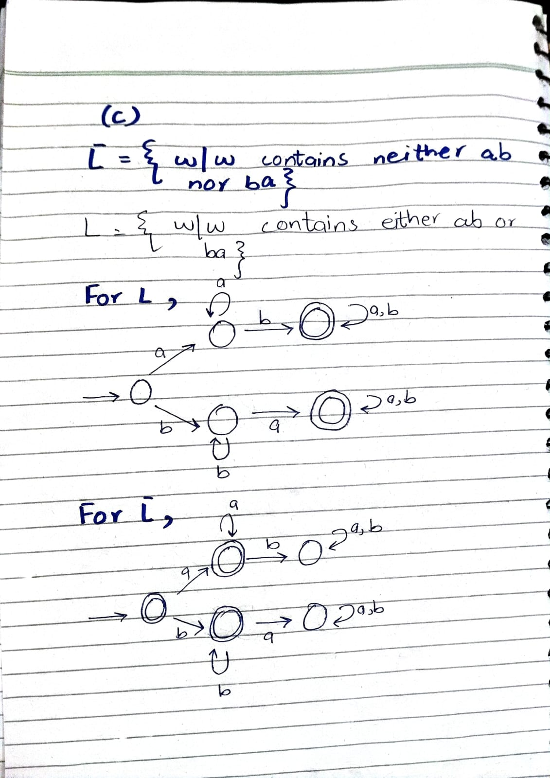

**Exercise 1.6:**

